

Alameda County Schools Insurance Group (ACSIG)
5776 Stoneridge Mall Rd., Suite 130 Pleasanton, CA 94588

AGENDA
Executive Committee

Date: Thursday, November 3, 2016
Time: 9:00AM
Location: Alameda County Office of Education
313 W. Winton Ave.
Hayward, CA 94544

- This meeting was called to order by Raul Parungao at 9:07 AM, with a quorum of members present.

- Roll call

Executive Committee Members
Raul Parungao Vice Present Fremont USD
Susan Kinder Secretary Livermore Valley Joint USD
Annette Heldman Board Member San Lorenzo USD
Akur Varadarjan Board Member New Haven USD

Kimberly Dennis Executive Director Alameda County Schools Insurance
Celina Flotte Executive Assistant Alameda County Schools Insurance

Tara Cooper-Salaiz Guest Keenan & Associates
Patrice Grant Guest Keenan & Associates
Ron Martin Guest Keenan & Associates
Michael Clark Guest Keenan & Associates
Dave Kundert Guest Keenan & Associates
Laurena Grabert Guest SETECH
Cary Allison Guest Morgan Stanley
Heather Daud Guest Christy White & Associates

- Acceptance of the Agenda
It was moved by Susan Kinder and seconded by Akur Varadarajan to approve the agenda as presented.

- Public Comment on Closed Session Agenda Items
No public present to comment.

Closed Session
Closed session began at 9:08 AM.

Open Session
Open session began at 9:15 AM.

- Public Comment on Open Session Agenda Items
No public present to comment.

- Report of Action Taken in Closed Session
It was moved by Annette Heldman and seconded by Akur Varadarjan to approve settlement authorizations and notifications listed below.
Ayes:, Varadarjan, Kinder, Parungao, and Heldman.
Nays: None.
Abstain: None.

- Settlement Authorization
- Claim Numbers:
417758 Ellis
431321 Lydon
436007 Ulloa
2203893 Gonzales
2206171 Dahl

- Settlement Notification
- Claim Numbers:
395548 Dasilva | 476764 Rodriguez | 503226 Butler | 2203815 Butler
404880 Gage | 477979 Irving | 504228 Guerrero | 2206040 Smith
412712 Butler | 482445 Ranier-Amenhotep | 505127 Gates | 2507710 Butler
422818 Cash | 491118 O'Neal | 505868 Alice
429441 Henares | 492470 Cordiano | 506362 Torres
443923 Butler | 495538 Guymon | 507222 Jensen
446337 Godinez | 500612 Cruz | 507649 Archibald
459020 Musleh | 501511 Battiste | 514232 Garcia
460805 Glenn | 501539 Kobb | 514395 Rios
469418 Godinez | 502786 Ness-McCulley | 520190 Cash

- Approval of Minutes

The Executive Committee reviewed meeting minutes from the Executive Committee meetings from May 19, 2016 and the Full Board minutes from May 26, 2016 and May 31, 2016. It was moved by Akur Varadarjan and seconded by Susan Kinder to approve the Executive Committee Meeting minutes from May 19, 2016 and the Full Board minutes from May 26, 2016 and May 31, 2016

General Business

- Election of Officers
Although Executive Committee members service a term of 2 years each, an officer’s term is only for one year. It was moved by Akur Varadarjan and Susan Kinder to keep in place Dr. Candi Clark as President, Raul Parungao as Vice President, and Susan Kinder as Secretary for the 2016/17 term.
Ayes: Kinder, Varadarjan, Parungao and Heldman.
Nays: None.
Abstain: None.

- 2015/16 Fourth Quarter Financials
Laurena Grabert from SETECH presented the 2015/16 fourth quarter financials.
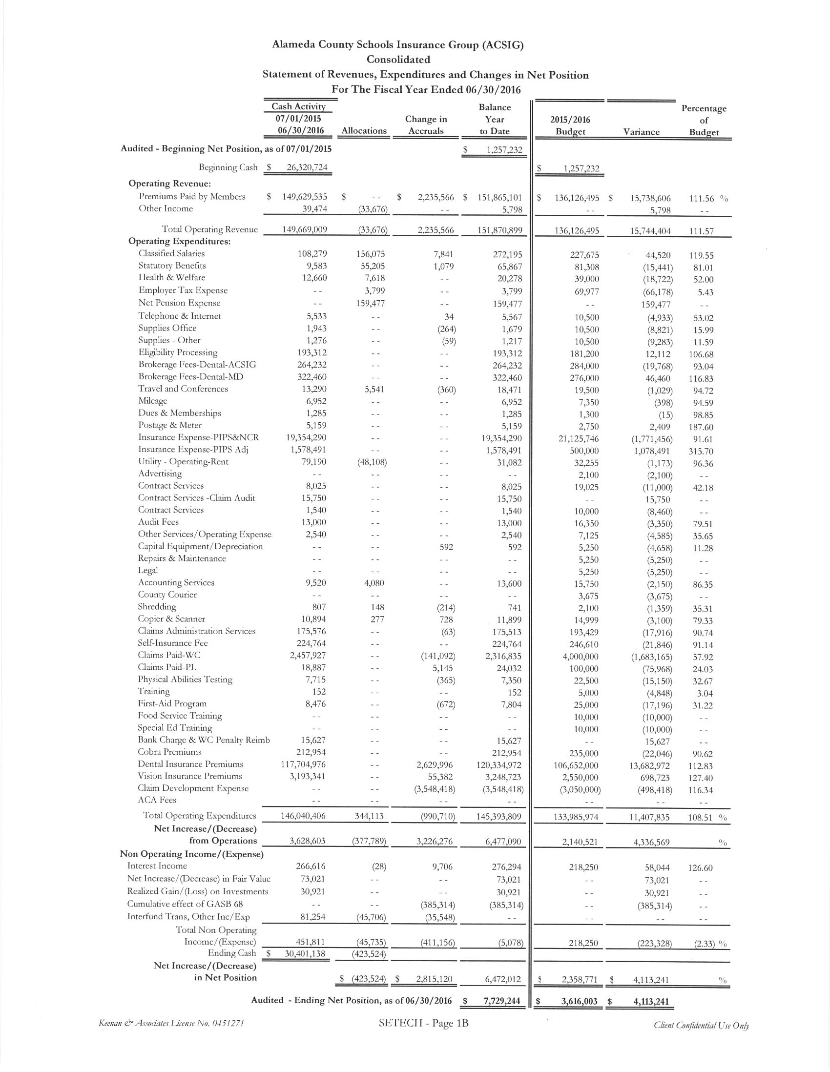

It was moved by Annette Heldman and seconded by Akur Varadarjan to approve the 2015/16 Fourth Quarter Financial Report to the Full Board consent calendar.
Ayes: Heldman, Kinder, Parungao and Varadarajan.
Nays: None.
Abstain: None.

- 2015/16 Audit
Heather Daud of Christy White & Associates reviewed the 2015/16 Audit with the Executive Committee. This was the fourth year with Christy White Associates and the audit went very smoothly with no findings.
It was moved by Susan Kinder and seconded by Akur Varadarajan to submit the 2015/16 Audit to the Full Board.
Ayes: Heldman, Kinder, Parungao and Varadarajan.
Nays: None.
Abstain: None.

- 2016/17 First Quarter Financials
Laurena Grabert from SETECH presented the 2016/17 first quarter financials.
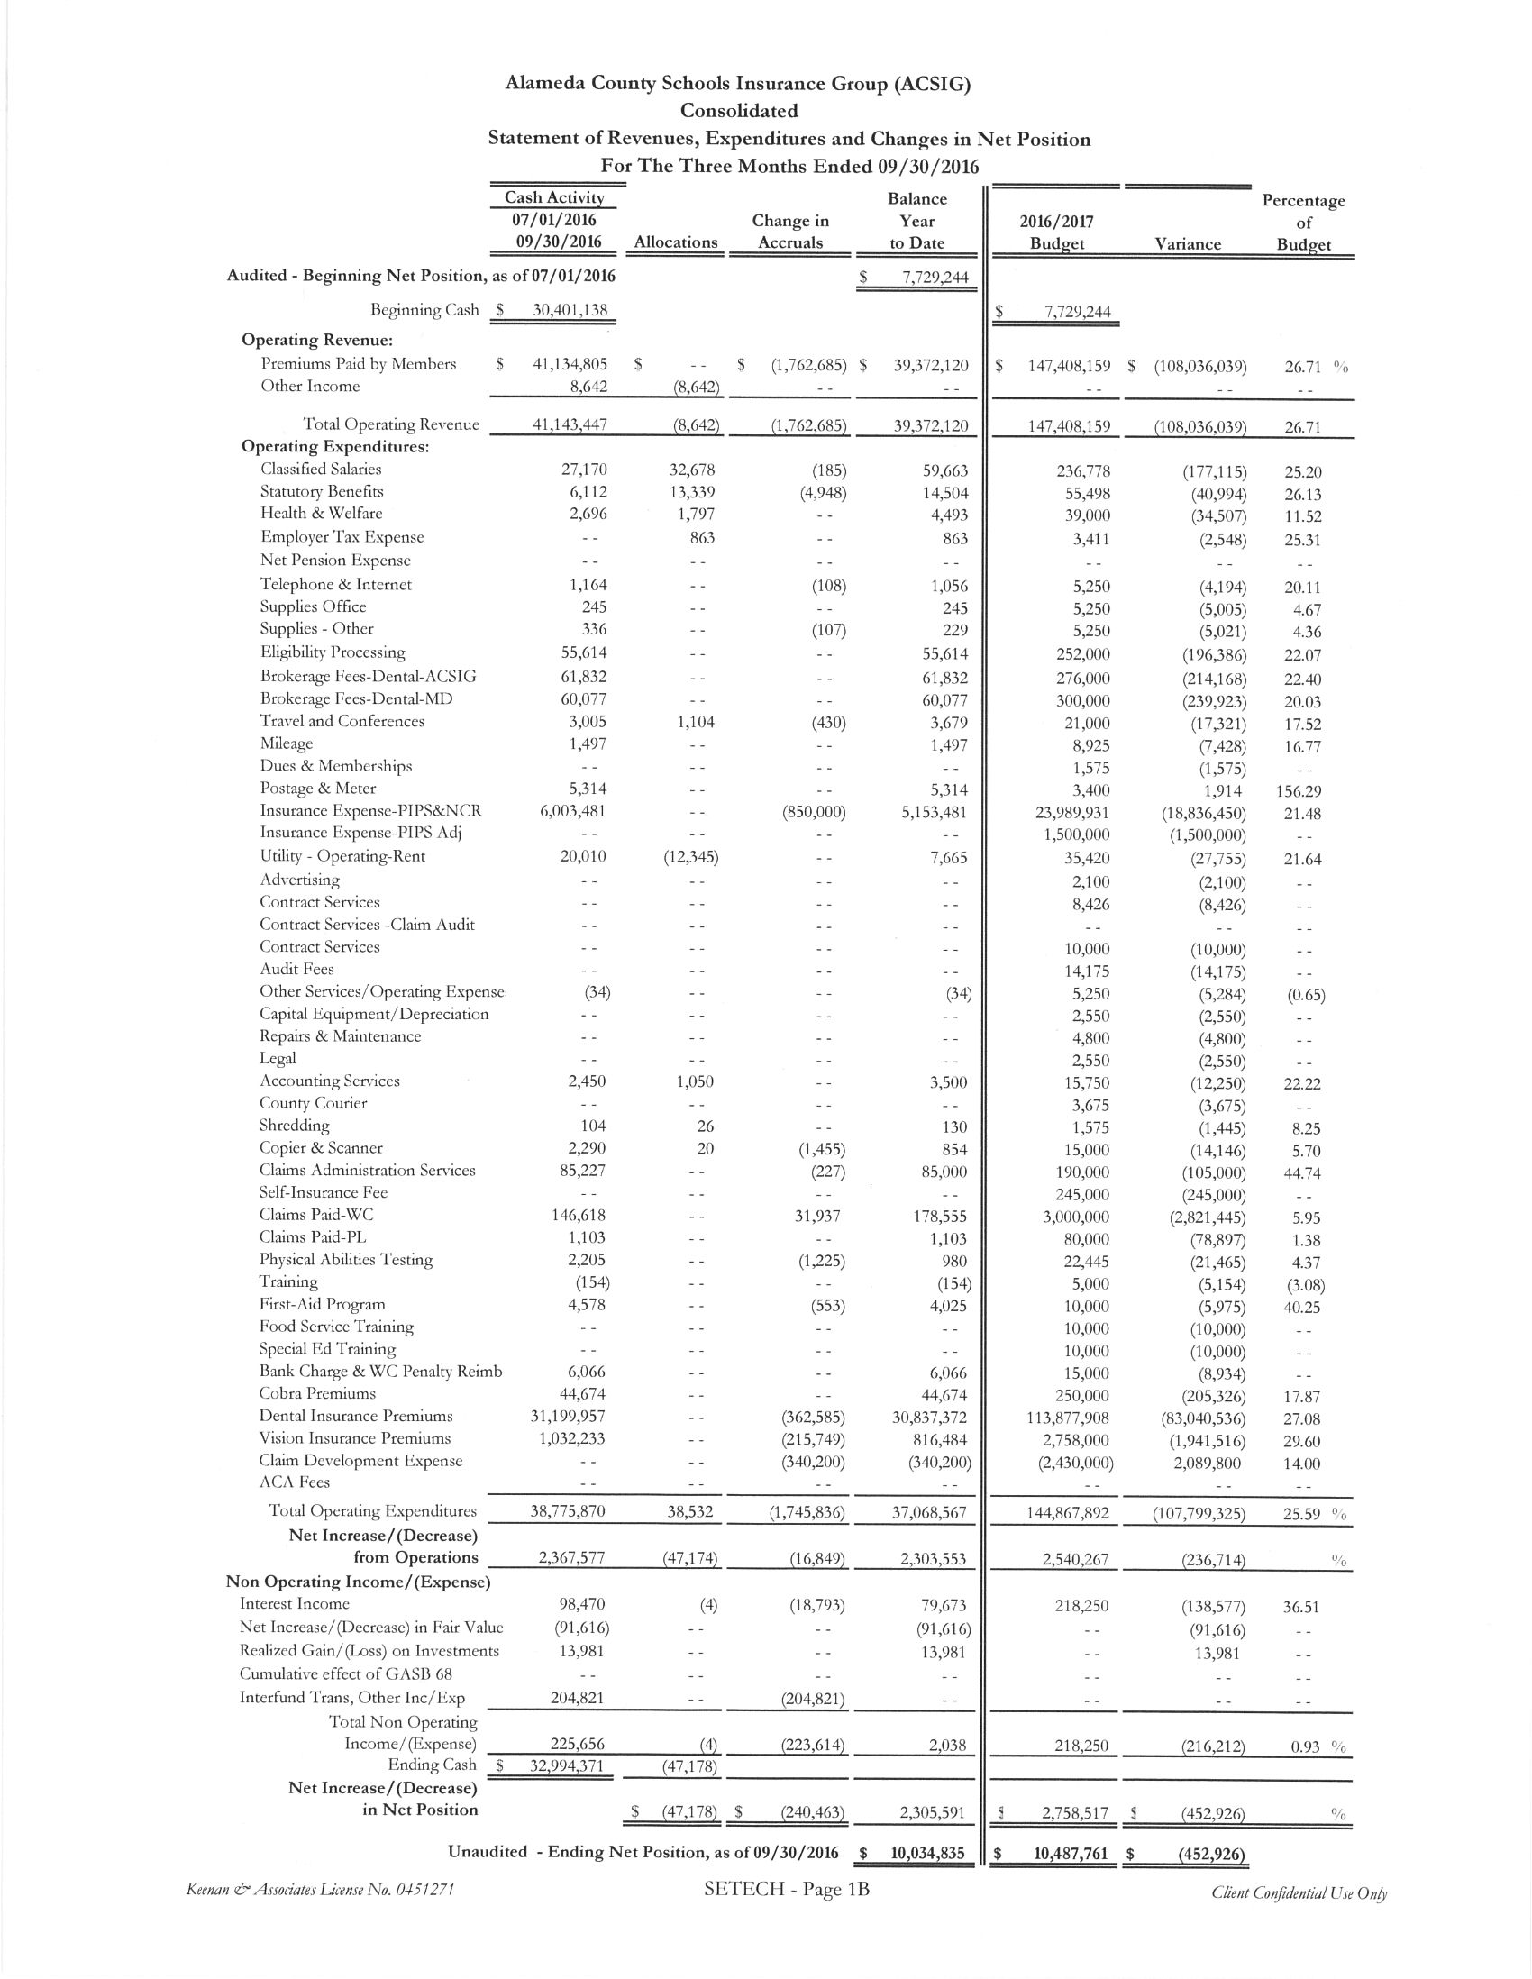

It was moved by Akur Varadarjan and seconded by Annette Heldman to submit the 2016/17 First Quarter Financial Report to the Full Board.
Ayes: Heldman, Kinder, Parungao and Varadarajan.
Nays: None.
Abstain: None.

- 2015/16 Fourth Quarter Investment Report
Cary Allison of Morgan Stanley presented the 2015/16 Fourth Quarter Investment Report.
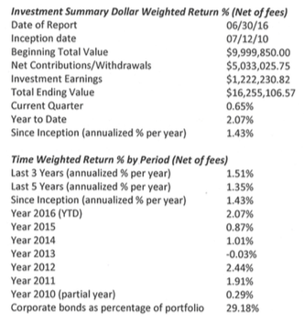

It was moved by Akur Varadarjan and seconded by Susan Kinder to approve the 2015/16 Fourth Quarter Investment report for the Full Board consent calendar.
Ayes: Heldman, Kinder, Parungao and Varadarajan.
Nays: None.
Abstain: None.

- 2016/17 First Quarter Investment Report
Cary Allison of Morgan Stanley presented the 2016/17 First Quarter Investment Report.
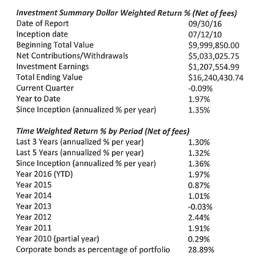

It was moved by Annette Heldman and seconded by Susan Kinder to submit the 2016/17 First Quarter Investment Report to the Full Board.
Ayes: Heldman, Kinder, Parungao and Varadarajan.
Nays: None.
Abstain: None.

- Annual Report
The Executive Director presented the 2015/16 Annual Report. The report will be presented to the Full Board at the meeting on November 9, 2016.

- Strategic Planning Summary
The Executive Director reviewed the Strategic Plan Report with the Committee. The report will be presented to the Full Board at the meeting on November 9, 2016.

Workers Compensation

- 2016/17 Service Plan
Tara Salaiz of Keenan reviewed the 2016/17 Service Plan with the Executive Committee. The service team consists of Tara Cooper-Salaiz as Account Manager, Michael Clark as Claims Analyst, Dave Kundert as Loss Control Consultant, Patrice Grant as Claims Manager, and Ron Martin as Account Executive. The Service Plan is a tool to show what the team wants to complete within the upcoming year. The team has chosen 4 target districts, including Alameda USD, Fremont USD, Newark USD, and Pleasanton USD.

- Company Nurse Update
Michael Clark of Keenan presented the Executive Committee with an update on the Company Nurse program expansion. Emery USD has now joined the program and the opportunity is still available to join if a district is interested.

- Workers Compensation Claims History & Deficit Review
The Executive Director reviewed the Workers Compensation Claims History and deficit review with the Executive Committee. Based upon a 2011 audit report, the program has an operating deficit of $19.6M ACSIG has accomplished milestone of eliminating this deficit. With the 2016/17 1st Quarter Financial Report, ACSIG is now projected to end the fiscal year with a surplus in this fund.

- Potential Exposure from Reinsurer Insolvency
Ron Martin of Keenan explained how 2 of ACSIG’s workers compensation claims are effected by our policy with CastlePoint. We anticipate that the assets of the company will pay the outstanding balances of these claims. Additionally, should there be insufficient funds to cover all claims, the California Insurance Guarantee Association (CIGA) will step in and pay $500,000 per claim.

- Future Planning

- Adjournment

