Alameda County Schools Insurance Group (ACSIG)
5776 Stoneridge Mall Rd., Suite 130 Pleasanton, CA 94588

MINUTES
Executive Committee

Date: Thursday, March 3, 2016
Time: 10:00AM
Location: Alameda County Office of Education
313 W. Winton Ave.
Hayward, CA 94544

- Dr. Candi Clark called the meeting to order at 10:05am, with a quorum of members present.

- Roll call

Executive Committee Members
Dr. Candi Clark President Castro Valley USD
Raul Parungao Vice President Fremont USD
Susan Kinder Secretary Livermore USD
Allan Garde Board Member Albany USD (Joined this meeting at 10:35am)
Annette Heldman Board Member San Lorenzo USD

Kimberly Dennis Executive Director Alameda County Schools Insurance
Celina Flotte Executive Assistant Alameda County Schools Insurance

Ron Martin Guest Keenan & Associates
Tara Cooper-Salaiz Guest Keenan & Associates
Patrice Grant Guest Keenan & Associates
Dave Kundert Guest Keenan & Associates
Kyle McGibbin Guest Keenan & Associates
Michael Clark Guest Keenan & Associates
Laurena Grabert Guest SETECH
Cary Allison Guest Morgan Stanley

- Acceptance of the Agenda
It was moved by Susan Kinder and seconded by Raul Parungao to approve the agenda as presented.
Ayes: Clark, Kinder, Parungao, Heldman
Nays: None
Abstain: None

- Public Comment on Closed Session Agenda Items
No public present to comment.

Closed Session
Closed session began at 10:06am.

Open Session
Open session began at 10:10am.

The claims notifications were reviewed in closed session but no action was taken.

- Public comment on Open Session Agenda Items
No public present to comment.

- Approval of Minutes
It was moved by Raul Parangao and seconded by Annette Heldman to approve the November 5, 2015 Executive Committee and Full Board Meeting minutes as presented.
Ayes: Clark, Parangao, Kinder, Heldman
Nays: None
Abstain: None

Workers Compensation

- Introduction of New Service Team Members
The Executive Director introduced the new Risk Management Analyst, Michael Clark & Loss Control Consultant, Dave Kundert.

- Results of PARS Audit
The Executive Director presented the results of the State Workers Compensation PARS Audit, with the Keenan/ ACSIG claims team receiving an outstanding score.
Recommendation: For discussion

- Forms Issue (DWC-1 Form Oversight)
The Executive Director has informed the Executive Committee of the new form change that has taken effect January 1, 2016.

- Actuarial Study – Ex Mod
The Executive Director presented the Ex-Mods as determined by the Actuary, Jack Joyce. Ex-Mods have a minimum of .75 and a maximum of 1.25. There is not a limit to the amount that a member can change between years. The amounts are averaged to 1.00 and based on a member’s experience within the pool. Positive risk management procedures will not have an immediate effect due to the numbers being based on a 3 year average, but will show positively in the future.

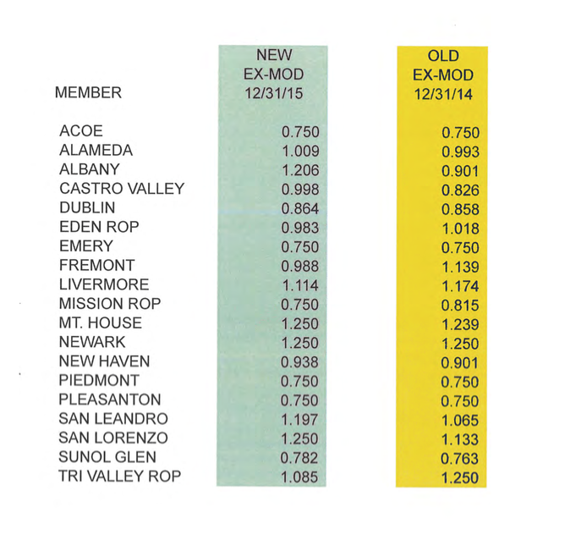
It was moved by Raul Parungao and seconded by Susan Kinder to approve the Actuarial Study Ex-Mods.
Ayes: Clark, Kinder, Parungao, Heldman
Nays: None
Abstain: None

- Actuarial Study – Ultimate Loss
The Executive Director presented the Ultimate Loss report prepared by Jack Joyce of Bay Actuarial. It was estimated that ACSIG’s liability for unpaid losses are $21,053,000 on December 31, 2015 and project that it will be $20,109,000 on June 30, 2016. The corresponding discounted values (at 1.5% interest) are $18,590,000 and $17,758,000. Last year it was estimated that the 12/31/14 liability would be $25.808 million. The new estimate of the 12/31/15 liability is $21.053 million.

- Preliminary 2016-2017 Workers’ Compensation Rates
The Executive Director reviewed the changes proposed to the base rate. 2016-2017 base rate uses a calculation of PIPS rate + Administrative Costs + Self Insurance Fee + an Adjustment of $1,500,000 + $0.35 for the deficit. The adjustment is for the payroll adjustment to accommodate the variance between payroll numbers used for ACSIG billing (2014-2015 audited payroll) versus the amount paid to PIPS (2016-2017 actual payroll). This payroll adjustment resulted in a 7.24% increase to the Worker’s Comp rate.

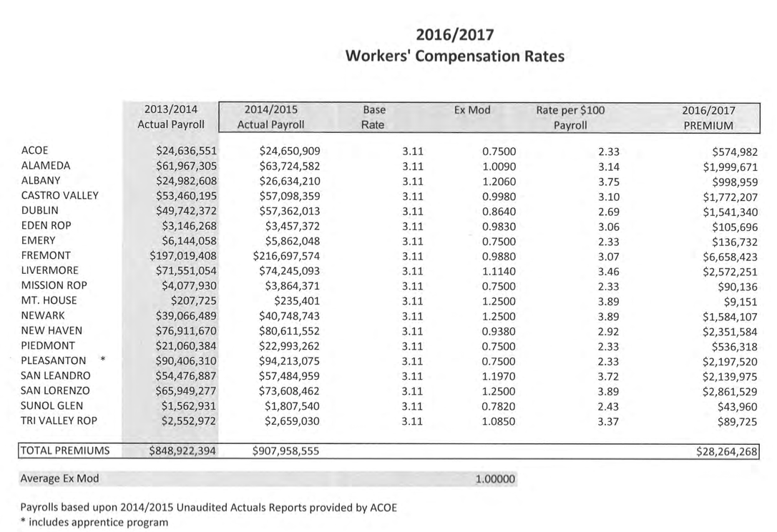
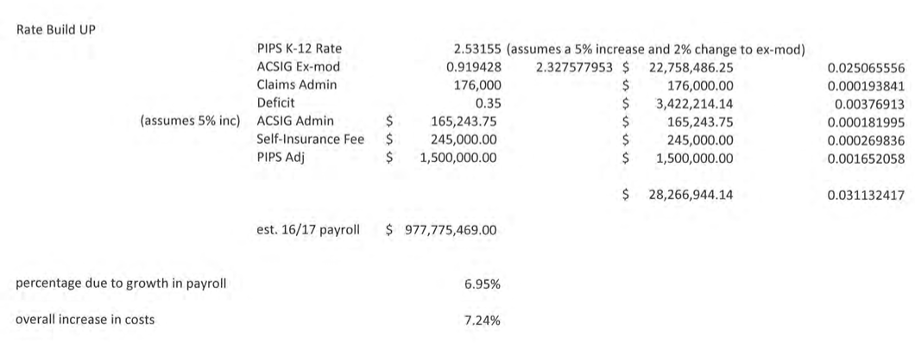

It was moved by Annette Heldman and seconded by Susan Kinder to approve the Preliminary 2016-2017 Worker’s Compensation Rates.
Ayes: Clark, Kinder, Parungao, Heldman
Nays: None
Abstain: None

- Claims Audit Proposal
The Executive Director reviewed a proposal from Wells Fargo for completion of an independent claims audit. In Spring 2016, ACSIG is requesting to contract with Wells Fargo to complete an independent claims audit of the ACSIG Worker’s Compensation claim operation.

It was moved by Raul Parungao and seconded by Annette Heldman to approve the Claims Audit Proposal.
Ayes: Clark, Kinder, Parungao, Heldman, Garde
Nays: None
Abstain: None

General

- Financial Audit Proposal
The Executive Director reviewed a proposal from Christy White Associates for 2016/17. ACSIG changed audit firms from Crowe Horwath (previously Perry=-Smith) to Christy White & Associates. They have successfully completed our audit for the past 2 years. The audit fee for fiscal year ending June 30, 2016 is $13,250.

It was moved by Raul Parungao and seconded by Allan Garde to approve the Financial Audit Proposal.
Ayes: Clark, Kinder, Parungao, Heldman, Garde
Nays: None
Abstain: None

- SETECH Contract
The Executive Director reviewed the proposed contract for SETECH, extending a 3-year service contract.

It was moved by Susan Kinder and seconded by Raul Parungao to approve the SETECH Contract.
Ayes: Clark, Kinder, Parungao, Heldman, Garde
Nays: None
Abstain: None

- Information Report for the Fiscal Year End
Laurena Grabert from SETECH presented the Financial Management Information Report Ended June 30, 2015. The following numbers reflect each member’s portion of the unfunded liability.

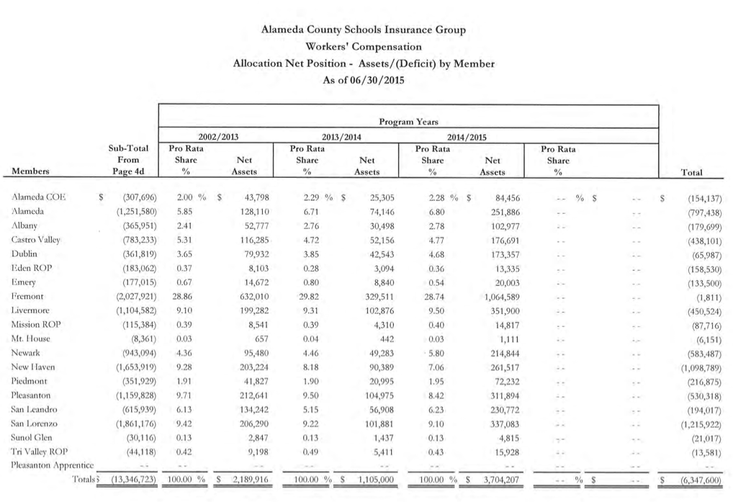

- Second Quarter Financial Report
Laurena Grabert from SETECH presented the 2015/2016 Second Quarter Financial Report.
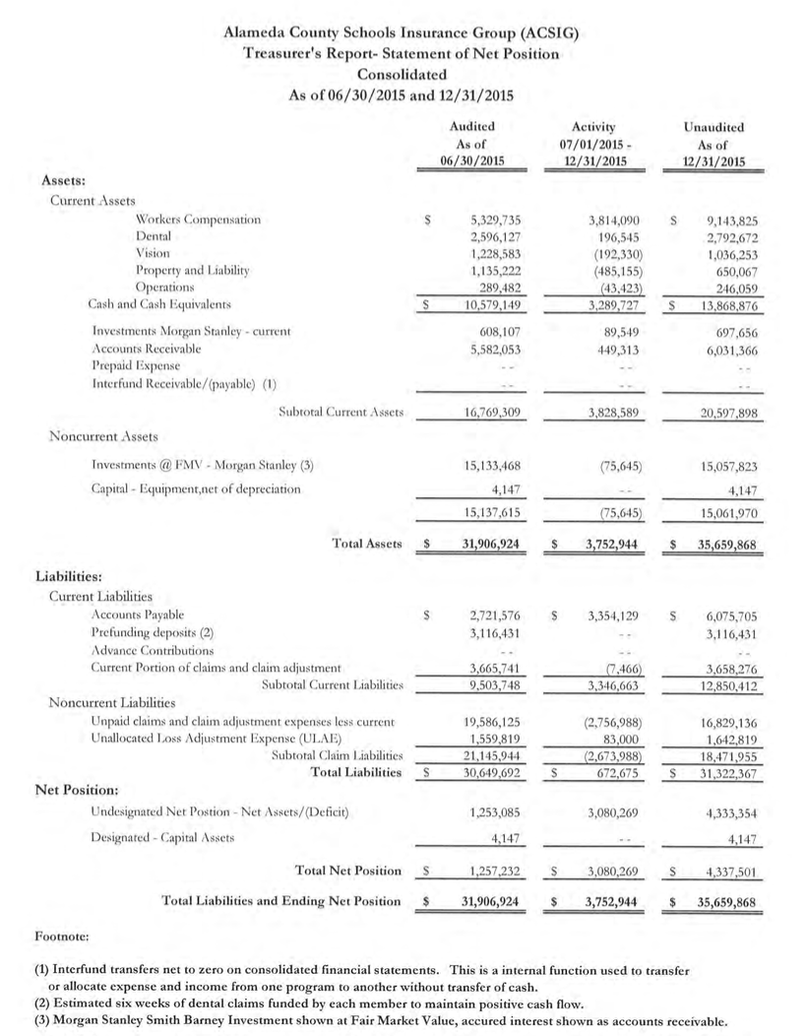
It was moved by Annette Heldman and seconded by Raul Parungao to approve the Second Quarter Financial Report.
Ayes: Clark, Kinder, Parungao, Heldman, Garde
Nays: None
Abstain: None

- Second Quarter Investment Report
Cary Allison from Morgan Stanley presented the 2015/16 Second Quarter Investment Report.

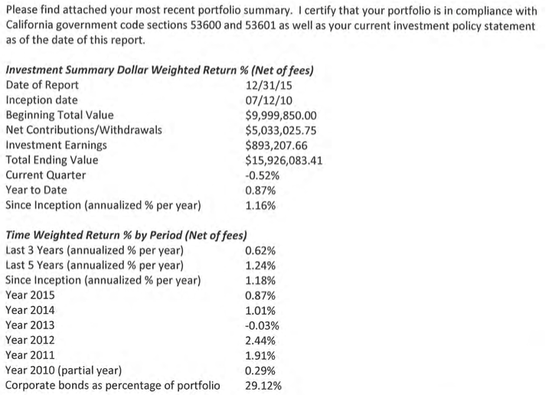

It was moved by Susan Kinder and seconded by Raul Parungao to approve the Second Quarter Investment Report.
Ayes: Clark, Kinder, Parungao, Heldman, Garde
Nays: None
Abstain: None

- 2016/2017 Budget
The Executive Director reviewed the tentative 2016/17 Budget. The budget was developed using year-to-date 2015/2016 data and preliminary estimates for 2016/2017 rates and costs. 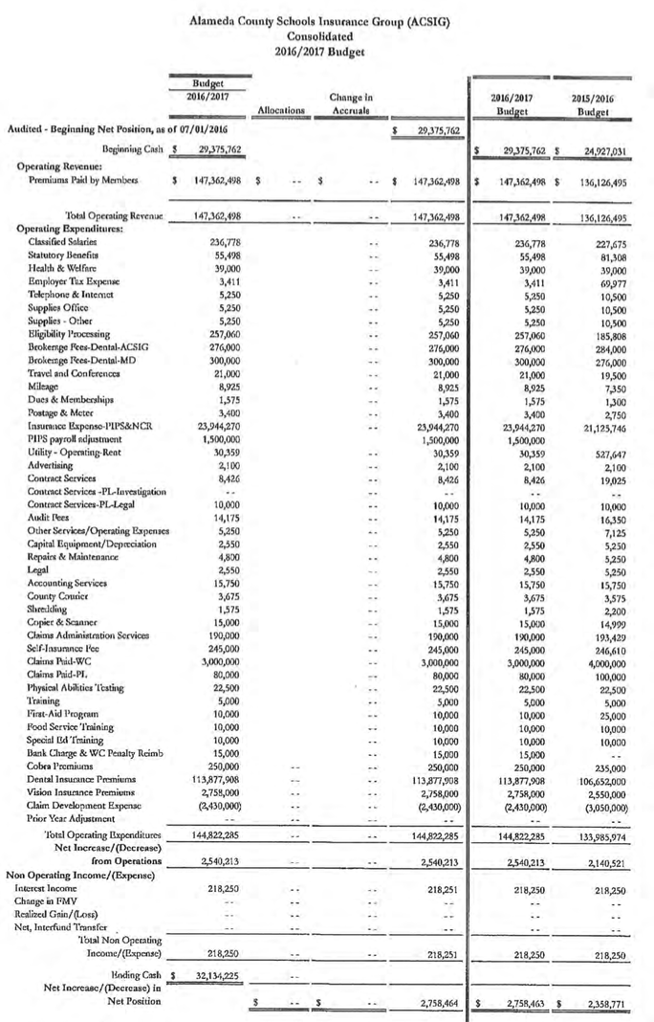

- Strategic Planning
The Executive Director reviewed options for 2016/17 strategic planning. We will begin to brainstorm on future planning and program growth.

- CAJPA Fall Conference 2016
The dates for the 2016 CAJPA Fall Conference will be September 13 -16 in Lake Tahoe. All Executive Committee Members and new Board Members are invited to attend.

- Safety Inspection Contract
The Executive Director reviewed the proposal from Keenan & Associates for safety inspections services that extends our term though June 30, 2018.

It was moved by Raul Parungao and seconded by Allan Garde to approve the Safety Inspection Contract.
Ayes: Clark, Kinder, Parungao, Heldman, Garde
Nays: None
Abstain: None

- Executive Director Quarterly Goals and Objectives
The Executive Director updated the Executive Committee on the progress of her Quarterly Goals and Objectives.

- Future Planning

- Dr. Candi Clark adjourned the meeting at 11:33AM.

