Alameda County Schools Insurance Group (ACSIG)
5776 Stoneridge Mall Rd., Suite 130 Pleasanton, CA 94588

MINUTES
Executive Committee

Date: Thursday, May 19, 2016
Time: 9:00 AM
Location: Alameda County Office of Education
313 W. Winton Ave.
Hayward, CA 94544

- Susan Kinder called the meeting to order at 9:08am, with a quorum of members present.

- Roll call

Executive Committee Members
Dr. Candi Clark President Castro Valley USD
Raul Parungao Vice President Fremont USD
Annette Heldman Board Member San Lorenzo USD
Akur Varadarajan Board Member New Haven USD

Kimberly Dennis Executive Director Alameda County Schools Insurance
Celina Flotte Executive Assistant Alameda County Schools Insurance

Ron Martin Guest Keenan & Associates
Tara Cooper-Salaiz Guest Keenan & Associates
Patrice Grant Guest Keenan & Associates
Dave Kundert Guest Keenan & Associates
Michael Clark Guest Keenan & Associates
Laurena Grabert Guest SETECH
Cary Allison Guest Morgan Stanley

- Acceptance of the Agenda
It was moved by Raul Parungao and seconded by Akur Varadarajan to approve the agenda as presented.
Ayes: Clark, Kinder, Parungao, and Varadarajan
Nays: None
Abstain: None

- Public Comment on Closed Session Agenda Items
No public present to comment.

Closed Session
Closed session began at 9:20am.

- Settlement Authorization
- Claim Numbers: None

- Settlement Notification
- Claims Number: 439197 Tomaryn; 448686 Duque; 457008 Kaye; 457276 Anastassiou; 458091 Hintze; 464418 Ortega; 472776 Promes; 473905 Perez; 476692 Vong; 480853 Hintze; 481012 Anastassiou; 481475 Miramontes; 482303 Supnet; 487730 Fregoso; 490109 Grasseschi-Robertson; 492283 Klindt; 498780 Martinez; 502042 Anastassiou; 502315 Shooter-Bilodeau; 507874 Matsumoto-Kim; 510601 Alexander; 516946 Costa; 2201229 Reichhoff; 2201862 Hazlett; 2205557 Cabanas

- Executive Director Evaluation

Open Session
Open session began at 9:33am.

- Public Comment on Open Session Agenda Items
No public present to comment.

- Report of Action Taken in Closed Session
No action was taken.

- Approval of Minutes
It was moved by Raul Parungao and seconded by Akur Varadarajan to approve the March 3, 2016 Executive Committee Meeting minutes with the corrections to name spellings.
Ayes: Clark, Kinder, Parungao, and Varadarajan
Nays: None
Abstain: None

Workers Compensation

- Result of Wells Fargo Independent Audit
The Executive Director presented the results of the Wells Fargo Independent Audit.
It was moved by Akur Varadarajan and seconded by Annette Heldman to approve the Wells Fargo Independent Audit as presented.
Ayes: Clark, Kinder, Parungao, and Varadarajan
Nays: None
Abstain: None

Dental

- Dental Rates 2016/2017
The Executive Director presented the 2016/2017 Dental rate recommendations to the Executive Committee. The program has been performing exceptionally well and efficiently. The past two years have seen flat rates and rebates in this program. The program operated at a very slight decrease in 2015/16. ACSIG has recognized a downward trend by keeping rates flat from year to year. This approach is continuing in 2016/17, however, no rebate is recommended.
It was moved by Akur Varadarajan and seconded by Raul Parungao to approve Dental Rates.
Ayes: Clark, Kinder, Parungao, and Varadarajan
Nays: None
Abstain: None

Vision

- Vision Rates 2016/2017
The Executive Director presented the 2016/17 Vision rate recommendations to the committee. The underwriting model shows a slight decrease in claim development within the past several years. In 2014/15 ACSIG reduced rates by 5.2%. The experience within 2015/16 continues to be positive with a flat renewal in 15/16. The fund is trending well and we are recommending a rate pass for 2016/17.
It was moved by Raul Parungao and seconded by Akur Varadarajan to approve the Vision rates as presented with no increase.
Ayes: Clark, Kinder, Parungao, and Varadarajan
Nays: None
Abstain: None

Property & Liability

- Property & Liability Rates 2016/2017
The Executive Director presented the 2016/17 Property and Liability rates. ACSIG has 5 members in the Property & Liability pool, which attaches to NCR at the $25,000 SIR. ACSIG’s current ex-mod is 1.29 within NCR. NCR rates have increased significantly. The rates for ACSIG are currently showing a 19.5% increase. Additionally, ACSIG needs to fund a $100,000 loss fund to pay our SIR for 2 claims in Property and 2 claims in Liability along with the $12,446 safety inspection.
It was moved by Akur Varadarajan and seconded by Annette Heldman to approve the Vision rates as presented with no increase.
Ayes: Clark, Kinder, and Parungao, Varadarajan
Nays: None
Abstain: None
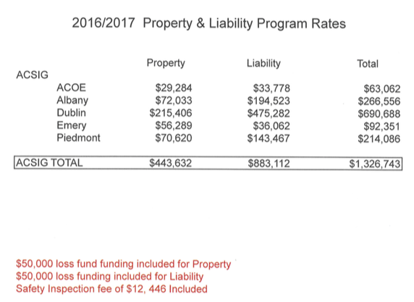

- PLCA Fee Amendment
The Executive Director presented a fee amendment to the PLCA contract. It was recommended for approval.
Recommendation: For action

General

- Third Quarter Financial Report
Laurena Grabert from SETECH presented the 2015/2016 third quarter financials report.
It was moved by Raul Parungao and seconded by Annette Heldman to approve the third quarter financial report rates as presented.
Ayes: Clark, Kinder, and Parungao, Varadarajan
Nays: None
Abstain: None

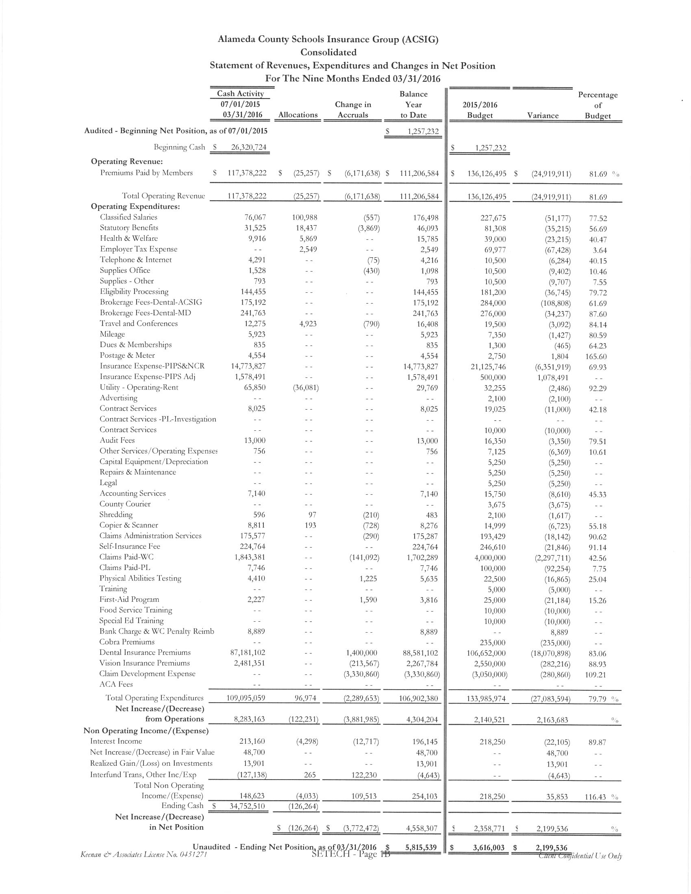
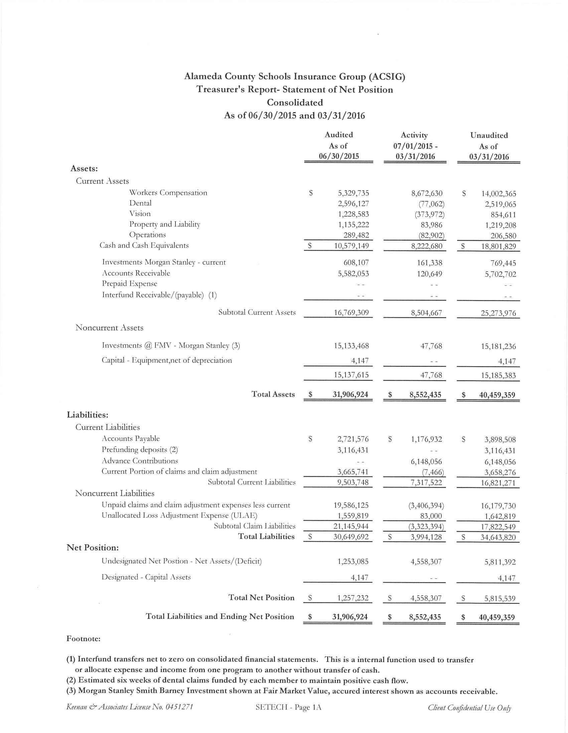

- Third Quarter Investment Report
The Executive Director reviewed the 2015/16 third quarter investment report with the Executive Committee.
It was moved by Annette Heldman and seconded by Raul Parungao to approve the third quarter investment report as presented.
Ayes: Clark, Kinder, and Parungao, Varadarajan
Nays: None
Abstain: None

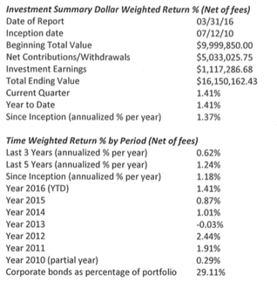

- 2016/2017 Budget
The Executive Director reviewed the 2015/16 Budget to the Executive Committee.
It was moved by Akur Varadarajan and seconded by Raul Parungao to approve the budget with one correction to the PIPS Payroll Adjustment line and Utility/rent.
Ayes: Clark, Kinder, and Parungao, Varadarajan
Nays: None
Abstain: None
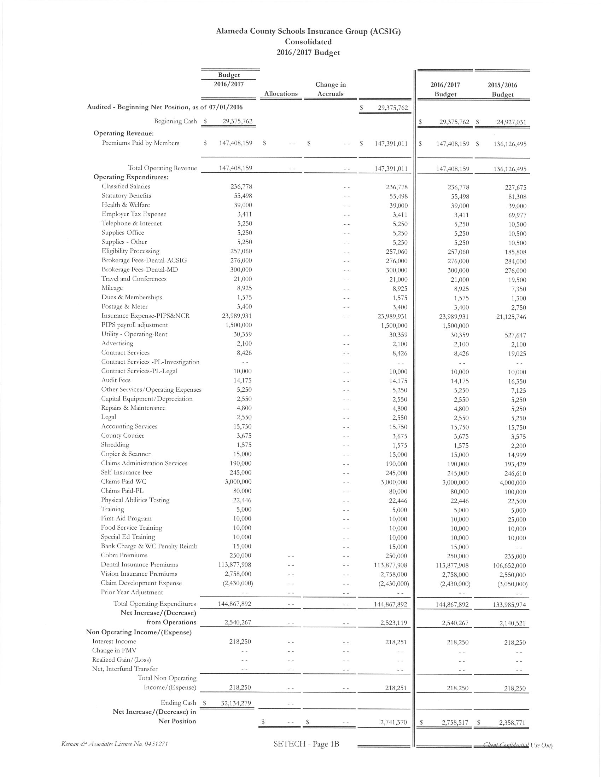

- ACSIG Salaries & Benefits
The Executive Director presented a cost of living increase proposal for the ACSIG staff of 3.5%. The average from 16 settled agencies was 3.71%. The overall cost for this increase would total $9,055.
It was moved by Akur Varadarajan and seconded by Raul Parungao to approve ACSIG salaries and benefits as presented.
Ayes: Clark, Kinder, and Parungao, Varadarajan
Nays: None
Abstain: None

- Strategic Plan 2016
The Executive Director has initiated some discussion topics for the 2016 Strategic Plan. We will send out dates for early July for this planning session to be organized.

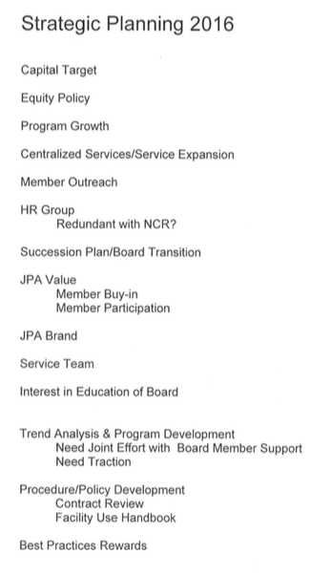

- Executive Committee Membership
The Executive Committee discussed possible Board Members for the recruitment to the Executive Committee.

Administrative

- Investment Policy
The Executive Committee conducted the annual review of the written investment policy and found no changes necessary.
It was moved by Raul Parungao and seconded by Annette Heldman to approve the Investment Policy as presented.
Ayes: Clark, Kinder, Parungao, and Varadarajan
Nays: None
Abstain: None

- Conflict of Interest Code
The Executive Committee conducted the annual review of the Conflict of Interest policy and found no changes necessary.
It was moved by Raul Parungao and seconded by Annette Heldman to approve the Conflict of Interest Code as presented.
Ayes: Clark, Kinder, Parungao, and Varadarajan
Nays: None
Abstain: None

- Authorization of Signatures
The Executive Committee conducted the annual review of the Authorization of Signatures and found no changes necessary.
It was moved by Raul Parungao and seconded by Annette Heldman to approve the Authorization of Signatures as presented.
Ayes: Clark, Kinder, Parungao, and Varadarajan
Nays: None
Abstain: None

- Meeting Calendar
The Executive Committee reviewed the 2016/17 draft calendar. The Executive Committee changed the Joint Full Board meeting from May 18, 2017 to May 25, 2017.

- Posting and Mailing Address
The Executive Committee conducted the annual review of the Posting and Mailing Address for ACSIG and found no changes necessary.
It was moved by Annette Heldman and seconded by Raul Parungao to approve the Posting and Mailing address as presented.
Ayes: Clark, Kinder, Parungao, and Varadarajan
Nays: None
Abstain: None

- Future Planning

- The meeting was adjourned at 10:33 am by Dr. Candi Clark.

