Alameda County Schools Insurance Group (ACSIG)
5776 Stoneridge Mall Rd., Suite 130 Pleasanton, CA 94588

AGENDA
Full Board

Date: Thursday, May 26, 2016
Time: 12:00PM
Location: Alameda County Office of Education
313 W. Winton Ave.
Hayward, CA 94544

- The meeting was called to order by Dr. Candi Clark at 12:10 PM

- Roll call

Board Members
Dr. Candi Clark President Castro Valley USD
Susan Kinder Secretary Livermore Valley Joint USD
Gary Jones Board Member Alameda COE
Allan Garde Board Member Albany USD
Dora Siu Board Member Emery USD
Dina Stewart Board Member Mountain House USD
Akur Varadarajan Board Member New Haven USD
Bryan Richards Board Member Newark USD
Song Chin-Bendib Board Member Piedmont USD
Michaela Ochoa Alternate Pleasanton USD
Annette Heldman Board Member San Lorenzo USD
Heather Morelli Alternate Tri-Valley ROP

Kimberly Dennis Executive Director ACSIG
Celina Flotte Executive Assistant ACSIG

Ron Martin Guest Keenan & Associates
Tara Cooper-Salaiz Guest Keenan & Associates
Patrice Grant Guest Keenan & Associates
Dave Kundert Guest Keenan & Associates
Michael Clark Guest Keenan & Associates
Laurena Grabert Guest SETECH

- Acceptance of the Agenda
It was moved by Susan Kinder and seconded by Gary Jones to accept the agenda as presented.
Ayes: Clark, Kinder, Jones, Garde, Siu, Stewart, Varadarajan, Richards, Chin-Bendib, Ochoa, Heldman, Morelli
Nays: None
Abstain: None

- Public Comment on Open Session Agenda Items
There was no public present to comment.

Consent Calendar
Review Items listed on the consent agenda for any adjustments and adoptions.

- SETECH Contract
- Safety Inspection Contract
- Executive Committee Minutes from November 5, 2015
- Executive Committee Minutes from March 3, 2016
- Full Board Minutes from November 5, 2015
- 2nd Quarter Financials
- 2nd Quarter Investment Report

It was moved by Akur Varadarajan and seconded by Song Chin-Bendib to approve the consent calendar as presented.
Ayes: Clark, Kinder, Jones, Garde, Siu, Stewart, Varadarajan, Richards, Chin-Bendib, Ochoa, Heldman, Morelli
Nays: None
Abstain: None

General

- Third Quarter Financials
Laurena Grabert from SETECH presented the 2015/2016 Third Quarter Financial statements.
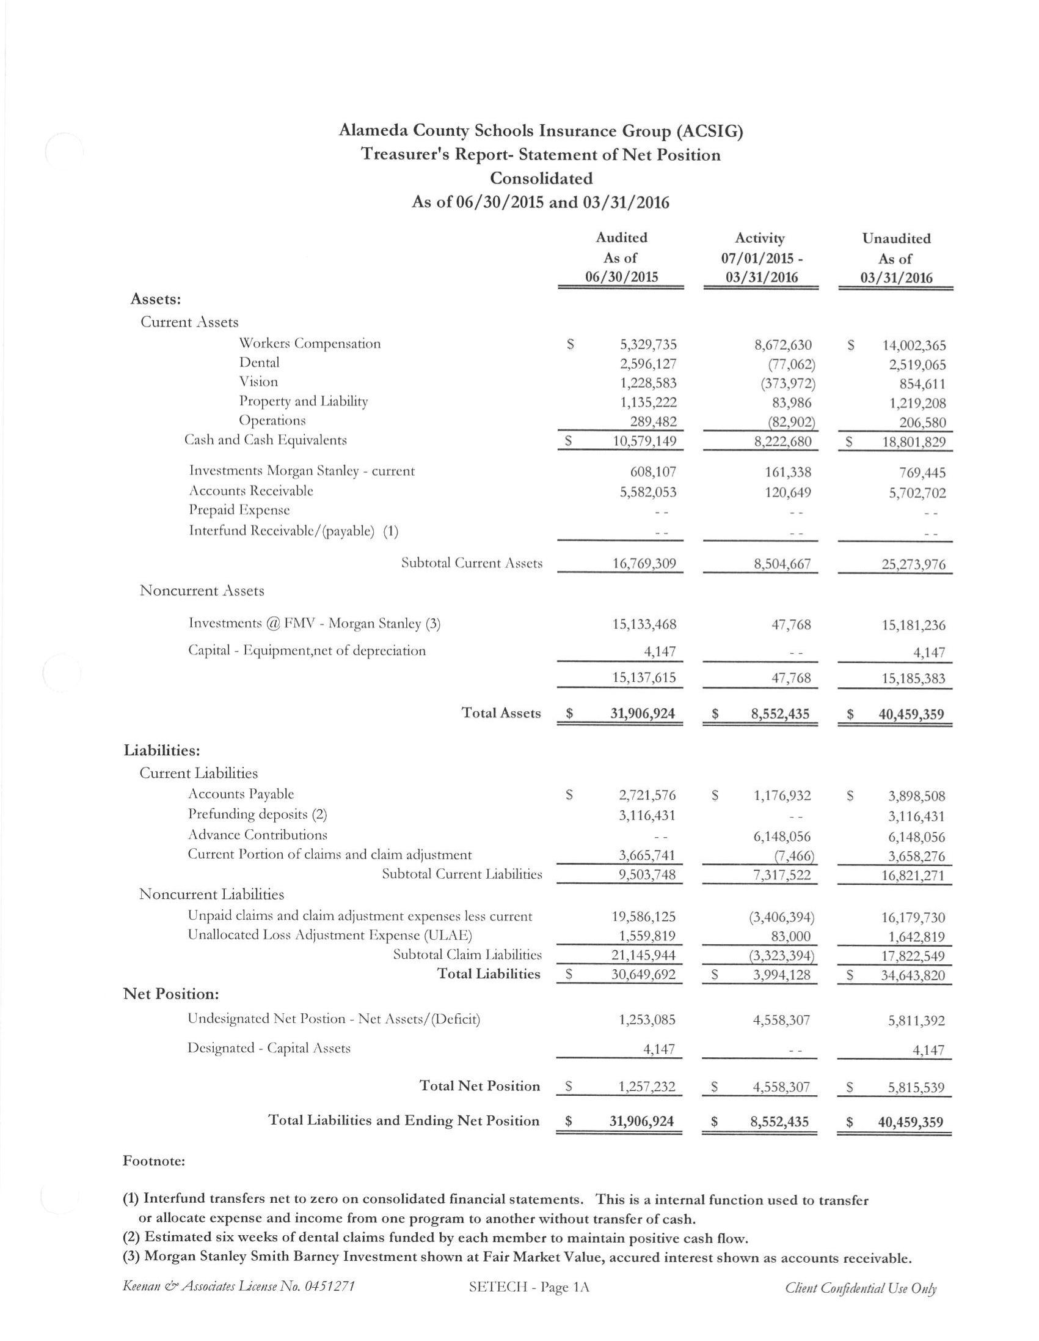 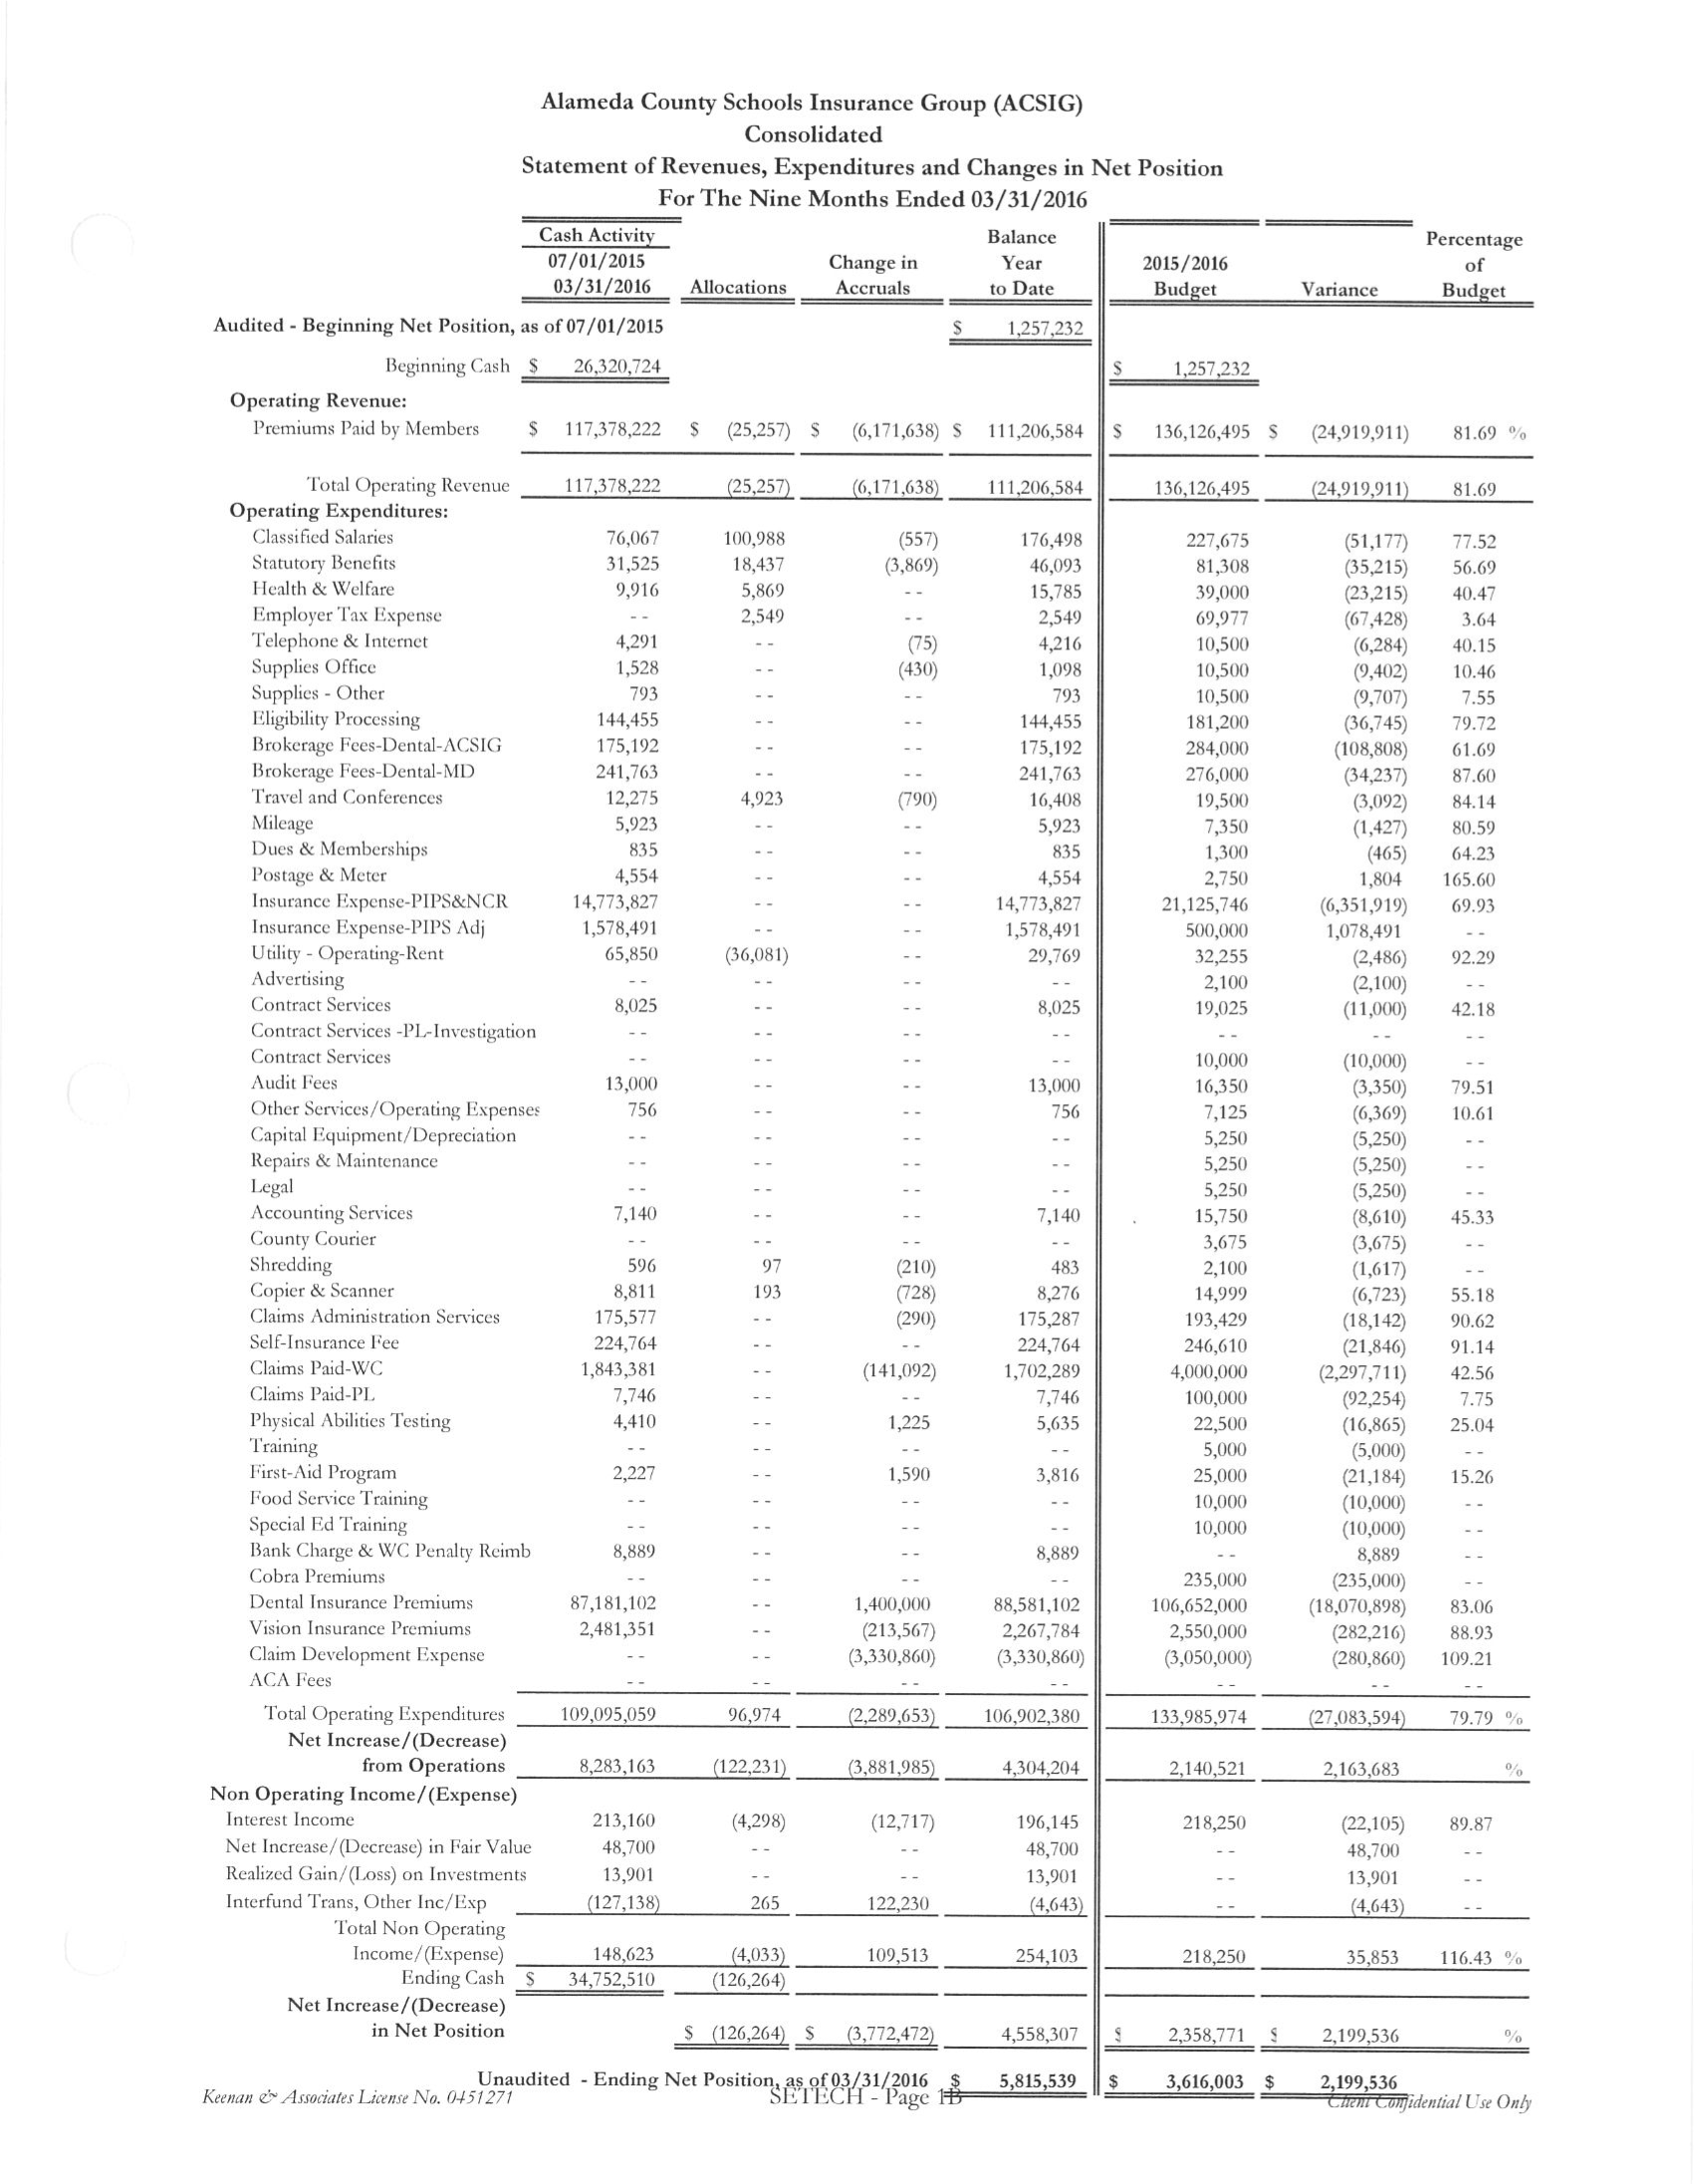It was moved by Annette Heldman and seconded by Akur Varadarajan to approve the Third Quarter Financials as presented.
Ayes: Clark, Kinder, Jones, Garde, Siu, Stewart, Varadarajan, Richards, Chin-Bendib, Ochoa, Heldman, Morelli
Nays: None
Abstain: None

- Third Quarter Investment Report
The Executive Director reviewed the 2015/16 Third Quarter Investment Report with the Board.
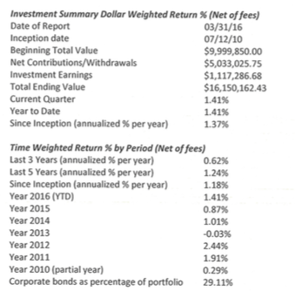
It was moved by Akur Varadarajan and seconded by Annette Heldman to approve the Third Quarter Investment Report as presented.
Ayes: Clark, Kinder, Jones, Garde, Siu, Stewart, Varadarajan, Richards, Chin-Bendib, Ochoa, Heldman, Morelli
Nays: None
Abstain: None

- 2016/2017 Budget
The Executive Director presented the 2016/2017 Budget to the Board. The budget was developed using year-to-date 2015/16 data and estimates for 2016/17 rates and costs. Salaries have been distributed to each program based upon a time-study. The assumptions are listed on the on the final pages of the budget.

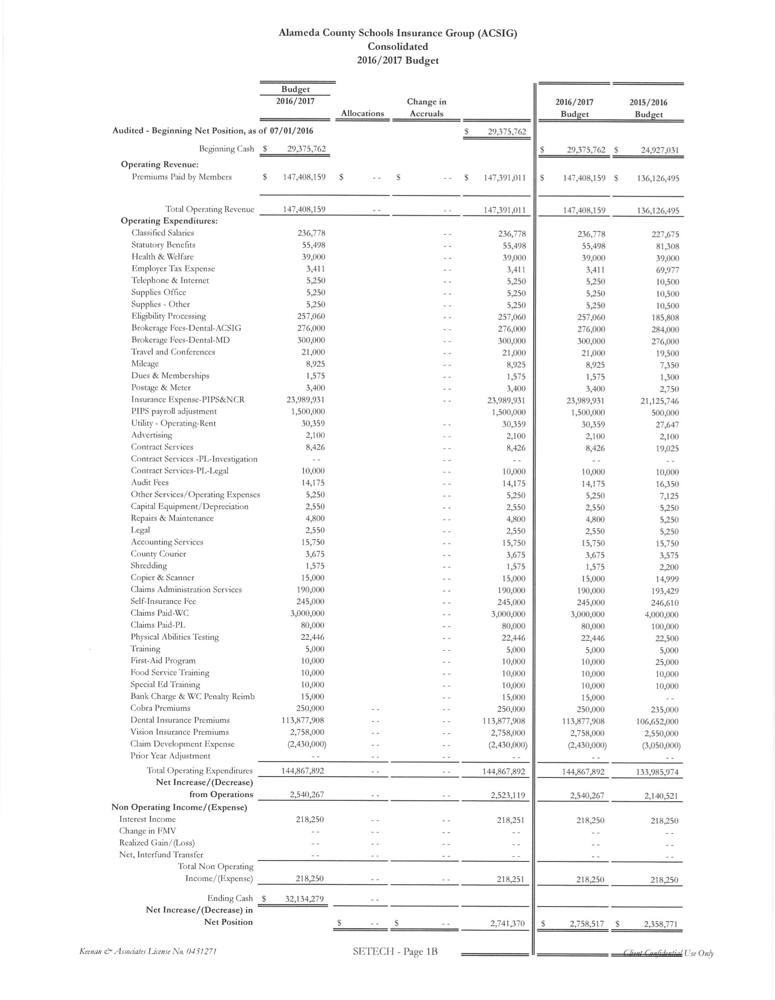
It was moved by Bryan Richards and seconded by Susan Kinder to approve the Budget as presented.
Ayes: Clark, Kinder, Jones, Garde, Siu, Stewart, Varadarajan, Richards, Chin-Bendib, Ochoa, Heldman, Morelli
Nays: None
Abstain: None

Dental

- Dental Rates 2016/2017
The Executive Director presented the 2016/2017 Dental rate recommendations to the Board. The program has been performing exceptionally well and efficiently. The past two years have seen flat rates and rebates in this program. The program operated at a very slight decrease in 2015/16. ACSIG has recognized a downward trend by keeping rates flat from year to year. This approach is continuing in 2016/17, however, no rebate is recommended.

It was moved by Dina Stewart and seconded by Gary Jones to approve the Dental Rates as presented.
Ayes: Clark, Kinder, Jones, Garde, Siu, Stewart, Varadarajan, Richards, Chin-Bendib, Ochoa, Heldman, Morelli
Nays: None
Abstain: None

Vision

- Vision Rates 2016/2017
The Executive Director presented the 2016/17 Vision rate recommendations to the Board. The underwriting model shows a slight decrease in claim development within the past several years. In 2014/15 ACSIG reduced rates by 5.2%. The experience within 2015/16 continues to be positive with a flat renewal in 15/16. The fund is trending well and we are recommending a rate pass for 2016/17.

It was moved by Bryan Richards and seconded by Akur Varadarajan to approve the Vision Rates as presented.
Ayes: Clark, Kinder, Jones, Garde, Siu, Stewart, Varadarajan, Richards, Chin-Bendib, Ochoa, Heldman, Morelli
Nays: None
Abstain: None

Property & Liability

- Property & Liability Rates 2016/2017
The Executive Director presented the 2016/17 Property and Liability rates to the Board. ACSIG has 5 members in the Property & Liability pool, which attaches to NCR at the $25,000 SIR. ACSIG’s current ex-mod is 1.29 within NCR. NCR rates have increased significantly. The rates for ACSIG are currently showing a 19.5% increase. Additionally, ACSIG needs to fund a $100,000 loss fund to pay our SIR for 2 claims in Property and 2 claims in Liability along with the $12,446 safety inspection.

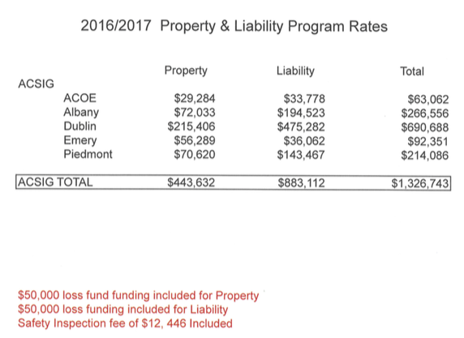
It was moved by Annette Heldman and seconded by Song Chin-Bendib to approve the P & L Rates as presented.
Ayes: Clark, Kinder, Jones, Garde, Siu, Stewart, Varadarajan, Richards, Chin-Bendib, Ochoa, Heldman, Morelli
Nays: None
Abstain: None

- Auxiliary/ Foundation Organizations - DUSD
The Executive Director presented the application for Amador Elementary and Kolb Elementary to the Board, and therefore need to endorse their parent clubs onto DUSD’s policy. The ‘site council’ should be removed from the application, as they are automatically covered under the district.

It was moved by Gary Jones and seconded by Allan Garde to approve the Auxiliary Club Endorsement with one change of removing the site council.
Ayes: Clark, Kinder, Jones, Garde, Siu, Stewart, Varadarajan, Richards, Chin-Bendib, Ochoa, Heldman, Morelli
Nays: None
Abstain: None

Workers Compensation

- Result of Wells Fargo Audit
The Executive Director presented the results of the Wells Fargo Independent Audit. Keenan & Associate continues to improve on their great work with our claims. They received an outstanding 4 out of 5 on this audit.

It was moved by Susan Kinder and seconded by Bryan Richards to approve the Wells Fargo Audit as presented.
Ayes: Clark, Kinder, Jones, Garde, Siu, Stewart, Varadarajan, Richards, Chin-Bendib, Ochoa, Heldman, Morelli
Nays: None
Abstain: None

- Actuarial Study – Ultimate Loss
The Executive Director presented the February 2016 Actuarial study of the ultimate loss of the self-insured portion of the ACSIG Workers Compensation program. Bay Actuarial estimates that ACSIG’s liability for unpaid losses was $21 million on December 31, 2014 and they project that it will be $20.1 million on June 30, 2015. The discounted estimate (1.5% interest) is $18.5 million on December 31, 2014 and $17.7 million on June 30, 2015.

It was moved by Bryan Richards and seconded by Song Chin-Bendib to approve the Actuarial Study Ultimate Loss as presented.
Ayes: Clark, Kinder, Jones, Garde, Siu, Stewart, Varadarajan, Richards, Chin-Bendib, Ochoa, Heldman, Morelli
Nays: None
Abstain: None

- Actuarial Study – Ex-Mods
The Executive Director presented the February 2016 Actuarial Study that determined the 2016/2017 program year experience modification factor. Experience Modification factor takes a look at ACSIG as a whole and how each member performs within the ACSIG program. As a whole, all numbers should equal 1 due to some members performing above average and some performing below. ACSIG as an entity approved the assumption that member will have an ex-mod below .75 and no member will have an ex-mod 1.25 to help protect one another.
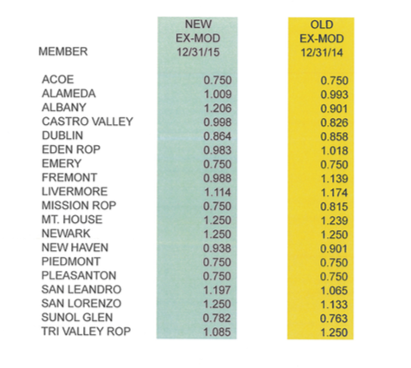
It was moved by Gary Jones and seconded by Akur Varadarajan to approve the Actuarial Study Ex-mods as presented.
Ayes: Clark, Kinder, Jones, Garde, Siu, Stewart, Varadarajan, Richards, Chin-Bendib, Ochoa, Heldman, Morelli
Nays: None
Abstain: None

- Workers Compensation Rates 2016/2017
The Executive Director presented 2016/2017 Workers Compensation rates. The base rate has increased from $2.90 to $3.11. 6.95% of that increase is due specifically to payroll growth. 7.24% is due to a slight increase in PIPS rate and administrative costs now being added to the Workers Compensation program.
Based upon the actuarial study, .35 cents is added per $100 of payroll towards reducing the deficit. To assist districts with budget planning, the 2016/20117 rates were based upon 2014/2015 audited payroll. But PIPS is paid based upon 2016/2017 actual payroll.
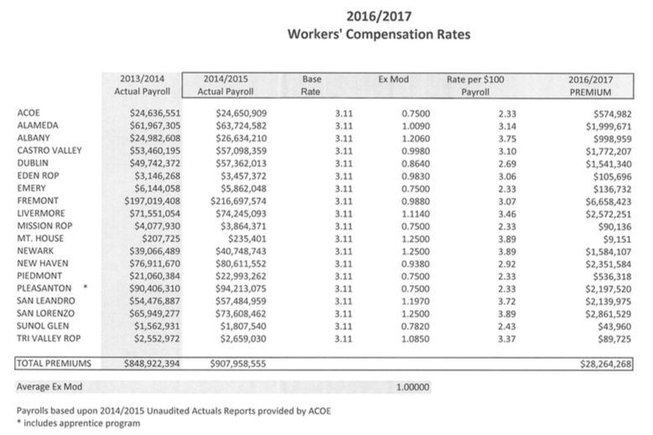
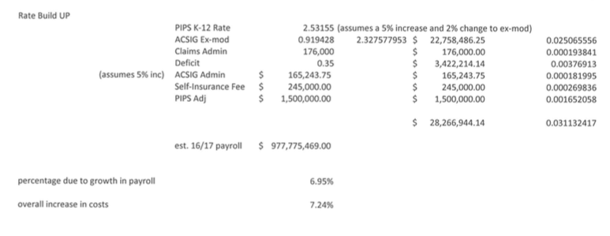
It was moved by Akur Varadarajan and seconded by Bryan Richards to approve the Workers Compensation Rates as presented.
Ayes: Clark, Kinder, Jones, Garde, Siu, Stewart, Varadarajan, Richards, Chin-Bendib, Ochoa, Heldman, Morelli
Nays: None
Abstain: None

- Informational Report for Fiscal Year End
Laurena Grabert from SETECH presented the 2015/2016 Informational Report for the Fiscal Year Ended June 30, 2015. The following numbers reflect each member’s portion of the unfunded liability.
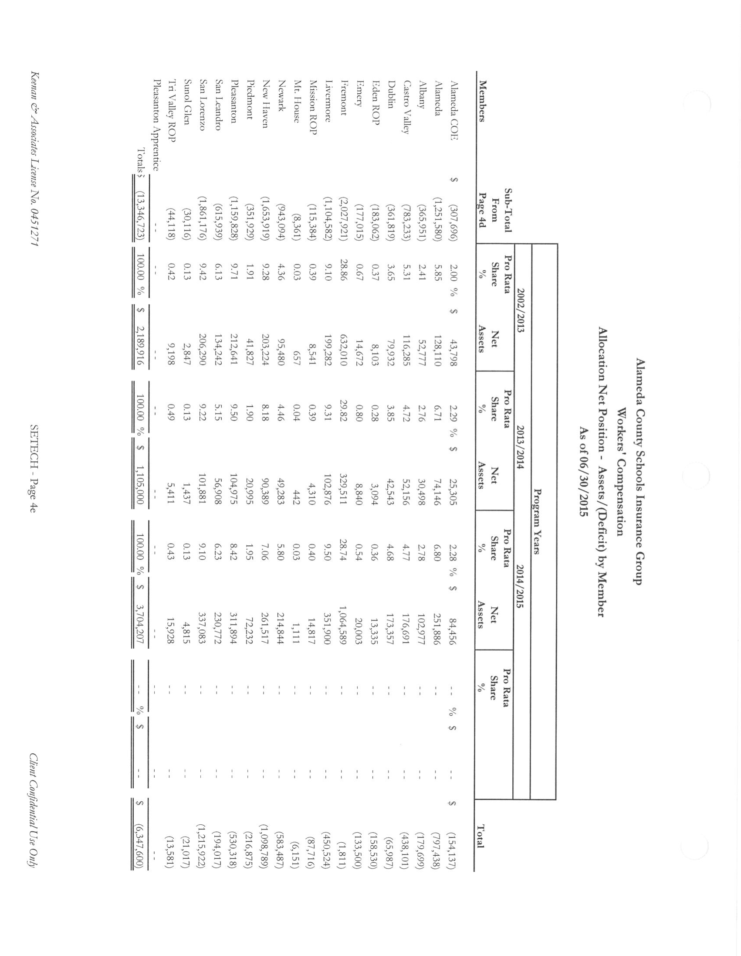

- Deficit Review
Based upon the 2011 audit report, the Workers’ Compensations program had an operating deficit of $19.6 million. SETECH estimates an improvement of over $9 million, bringing the total new estimate down to $3.3 million as of June 30, 2016. It is projected that deficit will be eliminated by December 2016, and an equity position by June 30, 2017.
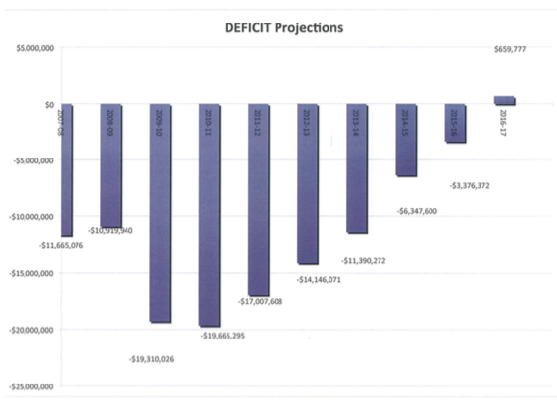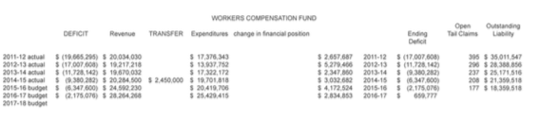

- 3 Year Point in Time Comparison
This report shows the frequency and severity of claims per district. This is a tool the service team uses help districts. This information is also used during file reviews with the teams at the district level.
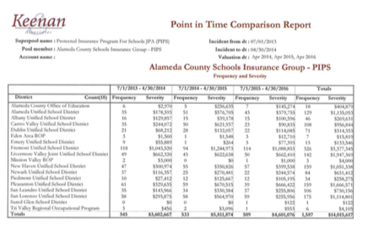

Administrative

- Election of Executive Committee
We currently have 4 seats up due to the rotation to serve through June 2018.
Susan Kinder, Annette Heldman and Allan Garde have agreed to sit for another 2 years. The Board was asked to nominate and vote on the election of one more member to join the Executive Committee.

It was moved by Akur Varadarajan and seconded by Gary Jones that current Executive Committee members Susan Kinder, Anette Heldman and Allan Garde serve another two-year term, and to elect Bryan Richards to join the Executive Committee.
Ayes: Clark, Kinder, Jones, Garde, Siu, Stewart, Varadarajan, Richards, Chin-Bendib, Ochoa, Heldman, Morelli
Nays: None
Abstain: None

- ACSIG Salaries & Benefits
The Executive Director presented a cost of living increase proposal for the ACSIG staff of 3.5%. The average from 16 settled agencies was 3.715%. The overall cost for this increase would total $9,055. This item was agendized as information only, therefore there is a conference call set up for Tuesday, May 31, 2016 to approve this salary increase by the Board.

- Meeting Calendar
The Full Board received the draft 2016/2017 calendar with the following meeting dates.
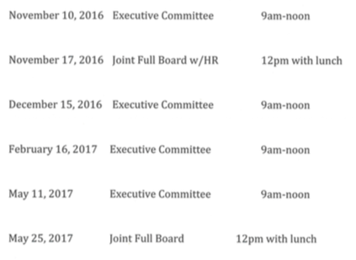

- Future Planning

- The meeting was adjourned at 1:09 PM by Dr. Candi Clark.

